MBSD Lab #4 A.Y. 2022/23

# Purposes

* Integrate the one pedal controller into a simulated Arduino Uno[1] microcontroller (C), resorting to SimulIDE[2].
* Interact with the C through its digital and analog interfaces.

# Instructions

For instruction on how to use SimulIDE and the Platform Support Packages[3] follow the instruction provided by Prof. Violante in the lecture of Thursday 11th May 2023.

The delivery shall contains:

* The controller Simulink model used to generate the firmware binary file (plus all the accompanying files needed to make it possible to generate again the code, like .m files containing initializations)
* The firmware binary file to be loaded into the simulated Arduino in SimulIDE
* The SimulIDE project file.
* The PDF or Microsoft Word version of the report.

It is available an example based on a Tank level controller, in the folder

The deliverable has to be provided as a .ZIP file up to **June 11th at 23:59.** It shall also contain a brief report explaining integration process using the following template. It is sufficient that only one of the group members uploads it.

# Model-Based Software Design, A.Y. 2022/23

# Laboratory 4 Report

## Components of the working group (max 2 people)

* Alessandro Cavalli, 301494
* Cihan Yurtsever, 296824

# I/O interfaces

*[Please describe the I/O interfaces to interact with the one pedal controller trough the electrical interfaces of the Arduino]*

*Since the Arduino Uno does not provide a CAN BUS interface, we assumed that the input and output signals are represented through a suitable voltage level.*

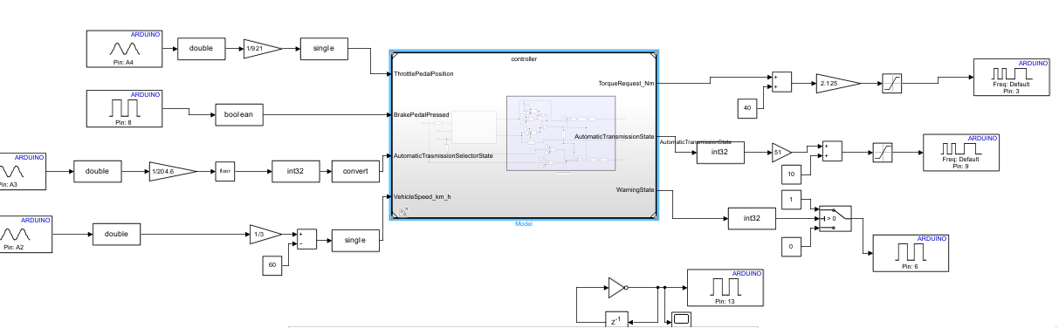

*Figure 1. The harness of the One Pedal System*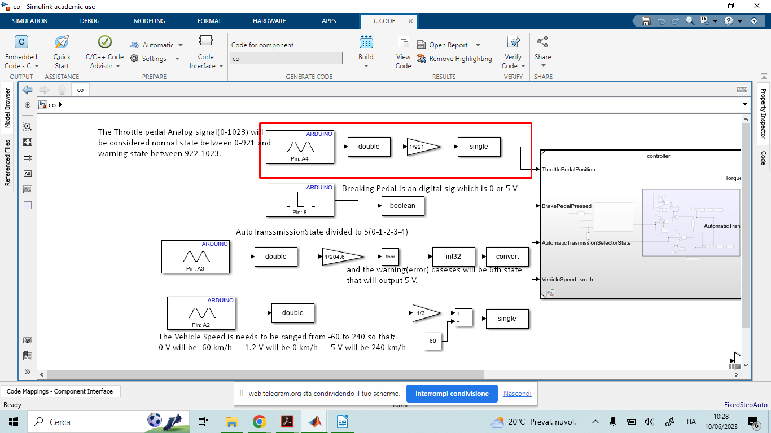

## *Figure 1.1 The Inputs of the Harness*

## *Figure 1.2 The Outputs of the Harness*

|  |  |  |  |  |  |
| --- | --- | --- | --- | --- | --- |
| **Name** | **Unit** | **Type[4]** | **Conversion formulas** | **Min[5]** | **Max** |
| ThrottlePedalPositionRaw (A4) | Volt/10bit | AI | A4/921 | 0 | 1023 |
| BrakePedalPressedRaw (D8) | No | DI | No | 0 | 1 |
| AutomaticTransmissionSelectorStateRaw(A3) | Volt/10bit | AI | floor(A3/204.6) | 0 | 1023 |
| VehicleSpeedRaw(A2) | Volt/10bit | AI | A2/3 - 60 | 0 | 1023 |
| TorqueRequestRaw(D3) | Volt/8bit | DO(PWM) | (TorqueRequest+40)*2.125 | 0 | 255 |
| AutomaticTransmissionStateRaw(D9) | Volt/8bit | DO(PWM) | (State*51)+10 | 0 | 255 |
| WarningStateRaw | No | DO | No | 0 | 1 |

*Notes:*

*ThrottlePedalPositionRaw is assumed to be an analog measurement acquired from a sensor which operates between 0V and 4.5V. If some error occurs, the output of such sensor will be greater than 4.5V. The conversion formula produces values greater than one in all the error cases so that the controller can detect the malfunction.*

*AutomaticTransmissionSelectorStateRaw is assumed to be an analog measurement acquired from a sensor wich operates between 0V and 5V. Each Volt corresponds to a state. 5V indicates a selector malfunction.*

*AutomaticTransmissionStateRaw is assumed to be fed into a Low pass filter network with losses. Therefore, in order to compensate the losses, an initial voltage bias of 10 Volt/8bit (0.2V) is applied.*

# Code generation for Arduino

*Step 1; Finishing all the charts make it ready to be generated..*

*Figure 2. Completed Algorithm of the One Pedal System*

*Step 2; Entering on the controller and setting the hardware and code generation configuration parameters..*

*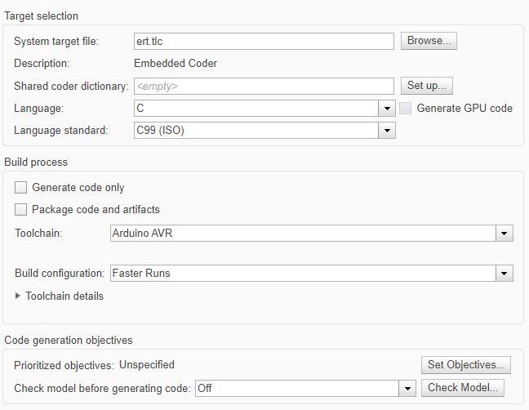Figure 2.1 Code Generation parameters*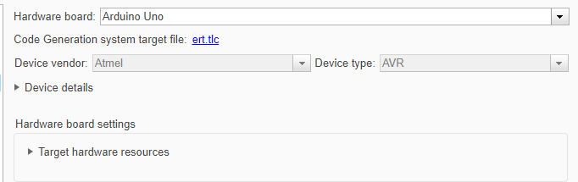

*Figure 2.2 Hardware Implementation parameters*

*Step 3; Generating the code..*

*Figure 2.3. Embedded Coder Interface*

*Building the code from the Embedded Coder app and from the interface selecting the Build.*

# Harness

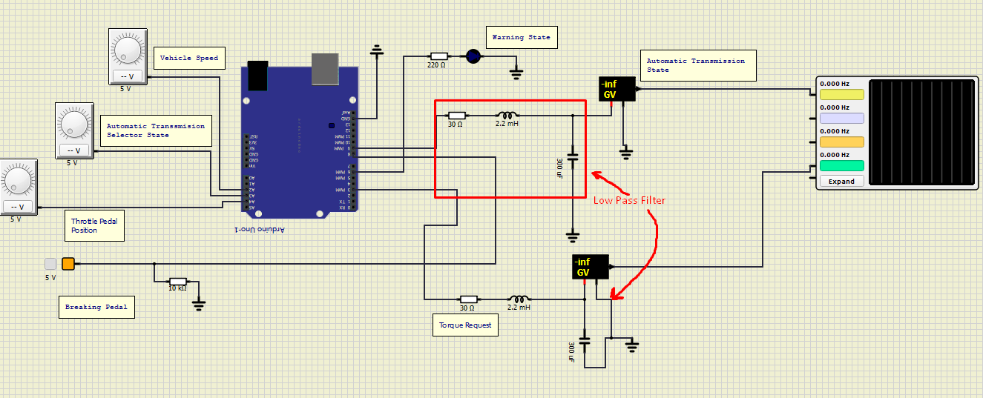*Figure 3. Harness of the SimulIde Model of One Pedal Controller*

## Test stimuli

The test inputs will be formatted in the following way

( BrakePedalPressedRaw, ThrottlePedalPositionRaw, AutomaticTransmissionSelectorStateRaw, VehicleSpeedRaw ).

All the units will be expressed in volts.

Reverse fail for brake(0,0,1,0.9) => no action

Reverse (5,0,1,0.9) => okReverse gas (0,0→4.5,1,0.9) => increasingly backward torque

Error gas (0,5,1,0.9) => warning led and swap to neutralNeutral (0,0,2,0.9) => ok

Drive fail for brake (0,0,3,0.9) => fail

Drive fail for speed (5,0,3,0) => fail

Drive (5,0,3,0.9) => ok

Brake fail for throttle (0,0,4,0.9) => fail

Brake (0,1.6,4,0.9) => ok

Brake gas (0,1.6→4.5,4,0.9) => increasingly forward torque

Brake regenerative (0,1.6→0,4,0.9) => increasingly backward torque

Error selector (0,1.6,5,0.9) => warning led and swap to neutral

Parked fail for speed(5,0,0,2.5) => fail

Parked fail for brake(0,0,0,0.8) => fail

Parked (5,0,0,0.8) => ok

*Some screenshots has been added to show part of the testing procedure.*

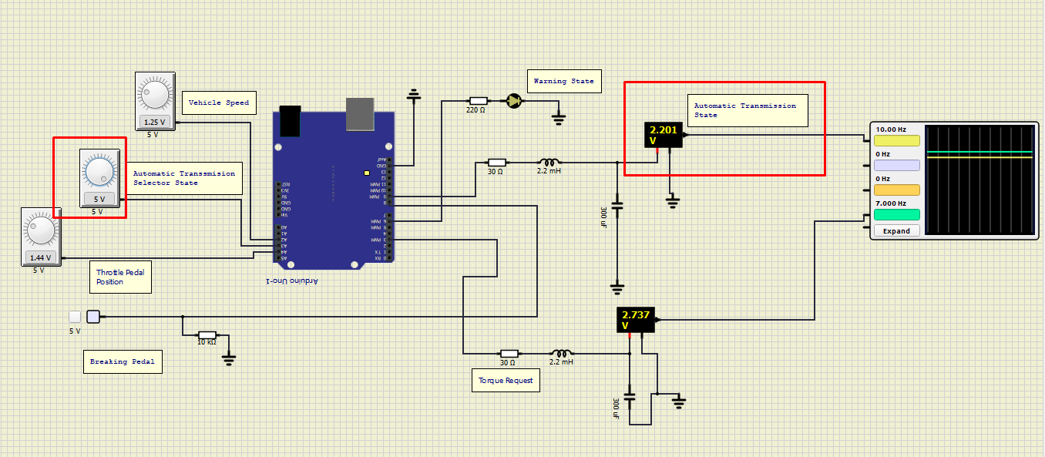Error for malfunction of the selector

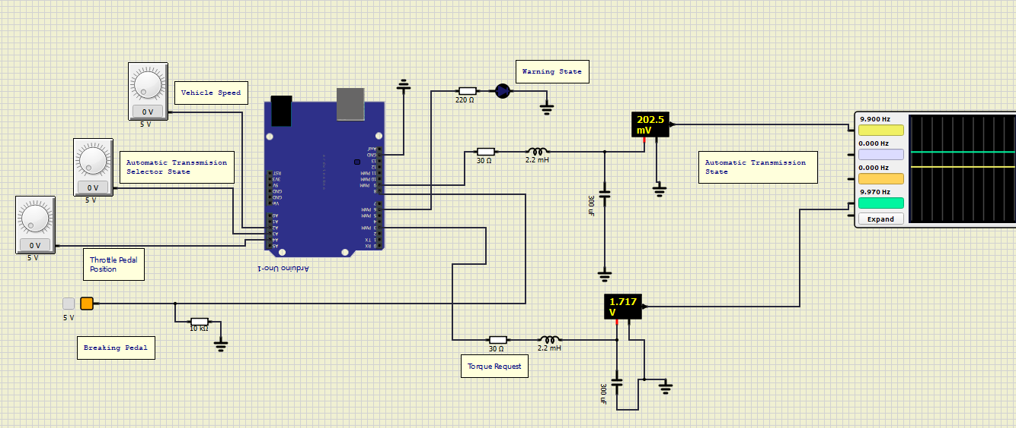parking state

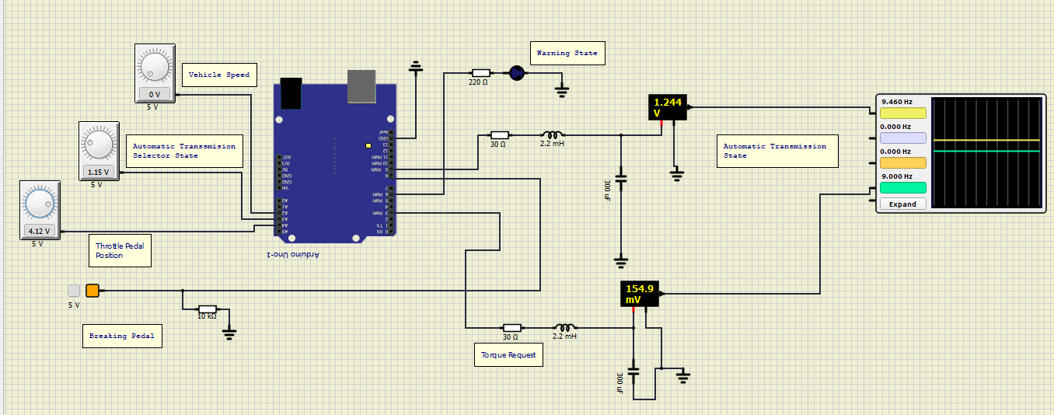reverse stete

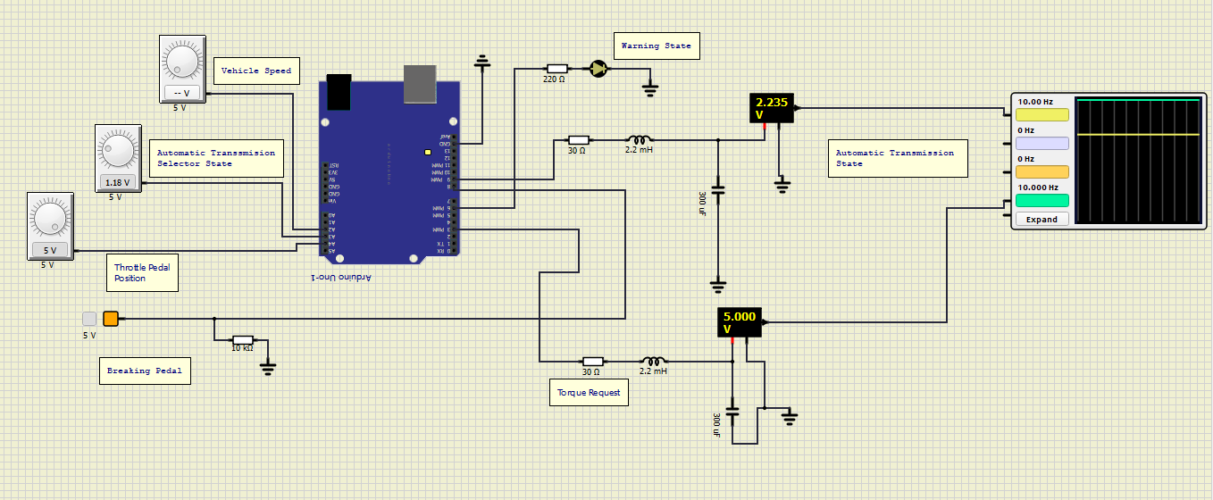Error for pedal malfunction

1. Arduino Uno Board Anatomy <https://docs.arduino.cc/tutorials/uno-rev3/BoardAnatomy>, last visited on 16/05/2022.
2. SimulIDE, https://www.simulide.com/p/home.html, last visited on 16/05/2022.
3. Simulink Support Package for Arduino Hardware and MATLAB Support Package for Arduino.
4. Digital Input (DI), Digital Output (DO), Analog Input (AI).

   For AIs, provide the conversion formula from input voltage to the measurement unit data (indicating also how to perform the conversion from the raw reading of the ADC).
5. The Min/Max values that can be handled due to the conversion formula shall be expressed in the measurement unit specified in the Unit column.